# CS 255 System Design Document Template

## UML Diagrams

### UML Use Case Diagram

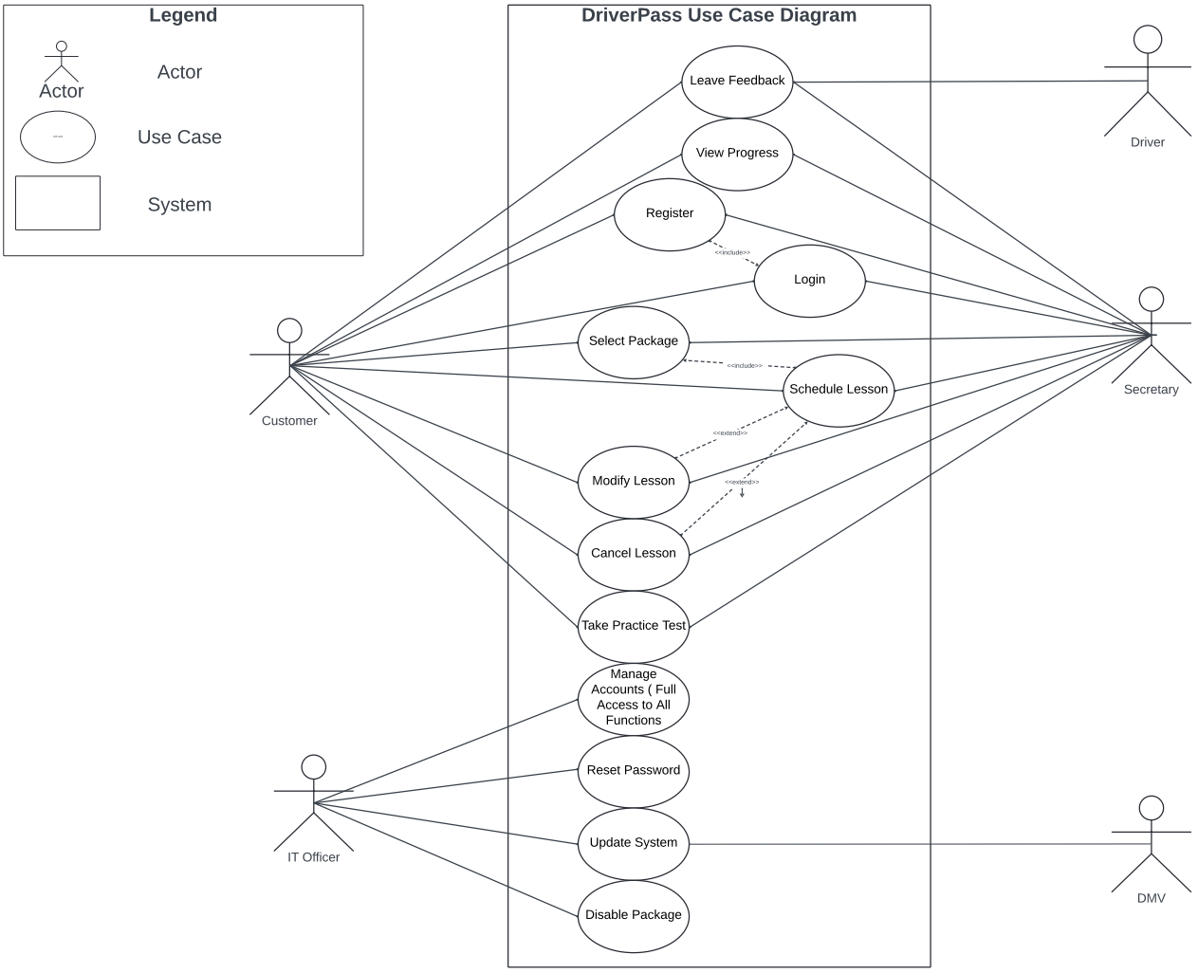

### UML Activity Diagrams

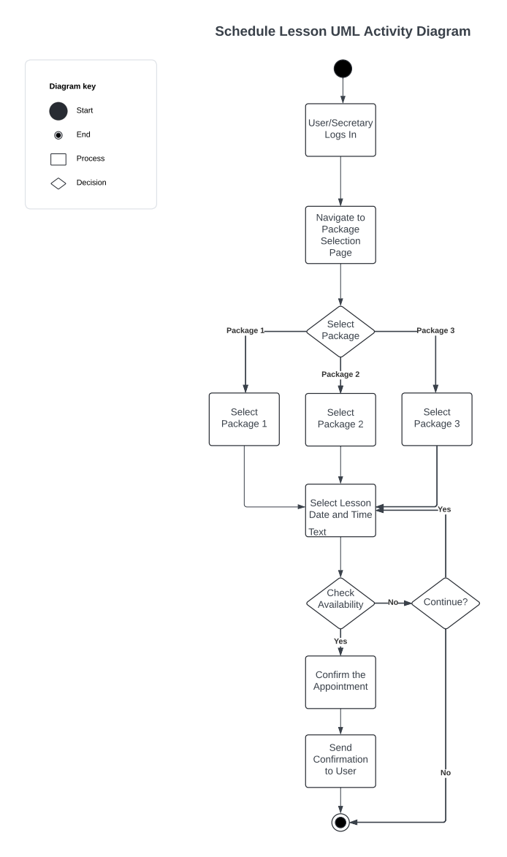

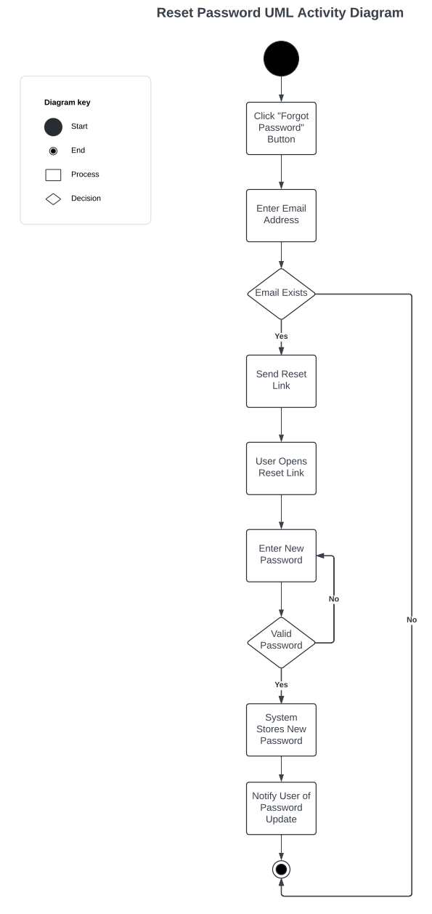

### UML Sequence Diagram

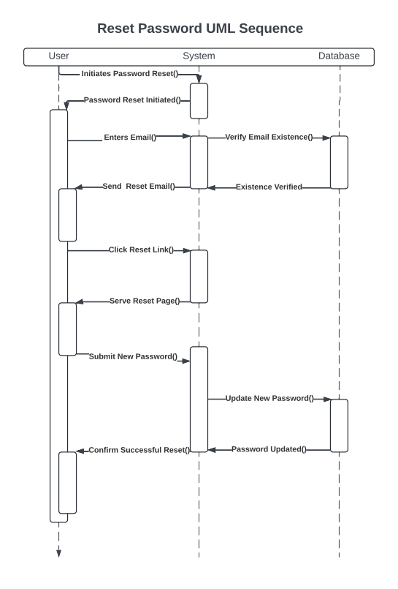

### UML Class Diagram

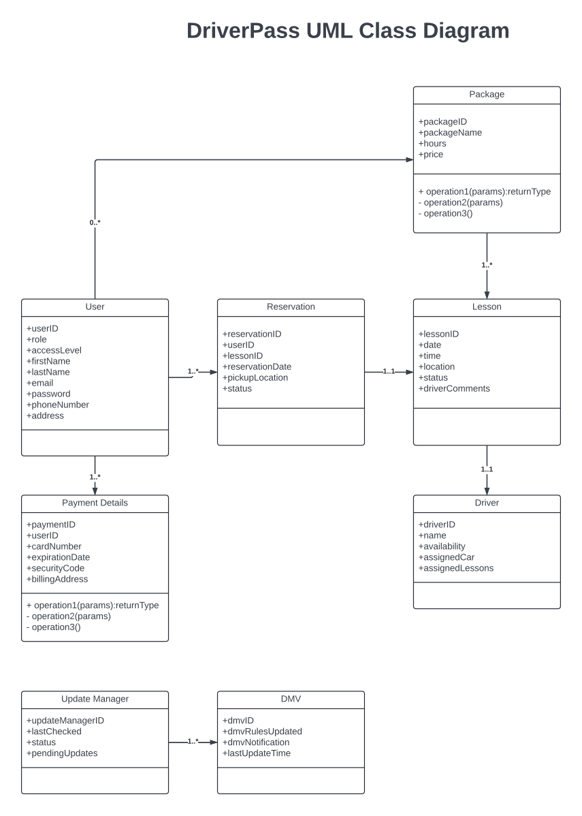

## Technical Requirements

As this system will be developed as a web application it must run on all modern browsers including Microsoft Edge, Mozilla Firefox, Safari, and Opera. Clients may not always run the latest updated version of their respective browser, because of this the application should be backwards compatible with releases up to two years older than production. The system and all system functions must run in the cloud where system and infrastructure updates will be handled by the cloud provider. The application must be able to handle many concurrent users each using distinct functions within the system such as scheduling, reviewing log reports, and managing account information. A multi-core compute instance or cluster will be necessary to handle the throughput of the system. Storage needs must be met using solid-state devices to ensure fast data transfer. The system should start with 16GB of ram but the cloud provider must allow for additional RAM provisioning when needed. The system itself must be accessible from all standard computing devices such as laptop, desktop, and mobile phone. On the server side the application should run on a stable version of Linux such as Ubuntu or Debian. This will ensure that the server is stable and compatible with role-based access control. A cloud database will also need to be provisioned. This database will need to store large volumes of customer data, activity logs, and transaction information. Because of this, a structured SQL database must be set up and resources provisioned for its use. The web server software must be compatible with Linux. Apache is recommended as an open source web server that will be able to securely and reliably handle the incoming HTTP requests. It will also facilitate communication between the different system components such as the database and the update manager. The system will need ongoing maintenance. Someone with strong Linux, web development, and server side development skills will be necessary to administer and update the system when needed. This administrator or IT Officer will need to be familiar with OpenSSL and modern encryption standards as well as role-based access control, firewall setup, antivirus software, threat avoidance, and other critical security elements.